**DAILY ONLINE ACTIVITIES SUMMARY**

|  |  |  |  |  |  |  |  |  |  |
| --- | --- | --- | --- | --- | --- | --- | --- | --- | --- |
| **Date:** |  | **05-06-2020** | | |  |  | **Name:** | **Suhas Prasad Shetty** | |
|  |  |  |  |  |  |  |  |  |  |
| **Sem & Sec** |  | **8th B** | | |  |  | **USN:** | **4AL16CS080** | |
|  |  |  |  |  |  |  |  |  |  |
|  |  |  |  |  | **Online Test** | | **Summary** |  |  |
|  | |  |  |  |  |  |  |  |  |
| **Subject** | |  | **BDA** | |  |  |  |  |  |
|  | |  |  |  |  |  | |  |  |
| **Max. Marks** | |  | **30** |  |  | **Score** | | **1** |  |
|  |  |  |  |  | |  | |  |  |
|  |  |  |  | **Certification Course Summary** | | | | | |
|  | |  | |  | |  | |  |  |
| **Course** |  | **AWS security fundamentals** | | | | | |  |  |
|  |  | | |  |  |  | |  |  |
| **Certificate Provider** | | | | **AWS** |  | **Duration** | |  | **2 hours** |
|  |  |  |  |  |  |  | |  |  |
|  |  |  |  |  | **Coding Challenges** | | |  |  |
|  | | | | |  |  |  |  |  |
| **Problem Statement-** : | | | | |  |  |  |  |  |
|  |  |  |  | **Write a Python program to convert seconds today, hour** | | | | | |
| **,minutes and seconds** | | | | |  |  |  |  |  |
|  | | | | |  |  |  |  |  |
| **Status: completed** | | | | |  |  |  |  |  |
|  | | | | |  |  | |  |  |
| **Uploaded the report in Github** | | | | |  | **yes** | |  |  |
|  | | | | |  |  | |  |  |
| **If yes Repository name** | | | | |  | **suhas** | |  |  |
|  | | | | |  |  | |  |  |
| **Uploaded the report in slack** | | | | |  | **yes** | |  |  |
|  |  |  |  |  |  |  |  |  |  |

**Online Test Details:**

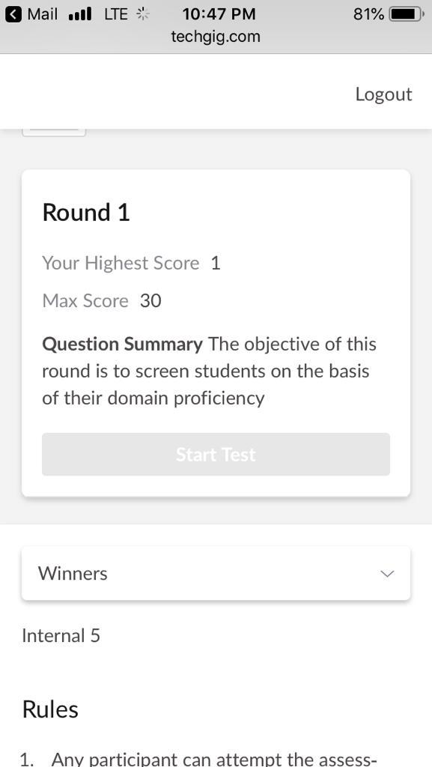

**Certification Course Details:**

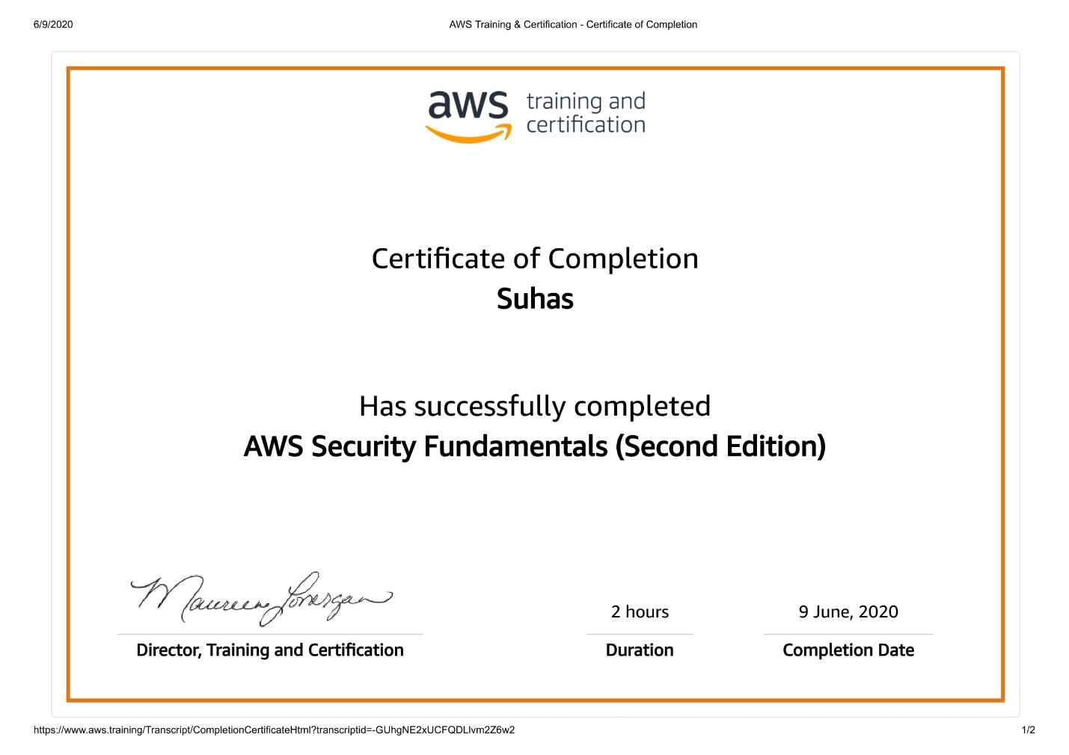

**Coding Challenges Details**

**time=float(input("Inputtimeinseconds:")**

**)**

**day=time**

**//(24*3600) time=time%(24*3600)**

**hour=time//3600**

**time%=3600**

**minutes=time**

**//60 time%=60**

**seconds=time print("day:->%d"%(day))**

**print("hour:->%d"%(hour))**

**print("minutes:->%d"%(minutes))**

**print("seconds:->%d"%(seconds))**